1-3-1 Short Response: Historical Bias

Instructions
 | After reviewing Zinn's and Schweikart's personal assumptions, beliefs, and values as well as excerpts from their historical writing, respond to the following questions:  - 1. What do you believe to be the major distinctions in their personal assumptions, beliefs, and values?  - 2. What do you believe to be the major distinctions in their interpretations of history?  - 3. Do you notice any biases? If so, what are they?

Perspectives: A Tale of Two Historians
 | In history, bias is defined as the incorporation of personal assumptions, beliefs, and values into historical writing. Sometimes this bias is conscious, and other times it is unconscious. Reading a bit more about a historian can help you understand their personal assumptions, beliefs, and values. In turn, this can help you understand what biases they might potentially introduce in their writing.  Two major historians, Howard Zinn and Larry Schweikart, have written popular books on American history containing very different historical interpretations of the same events. Explore this interactive resource on Zinn and Schweikart to learn about their different personal assumptions, beliefs, and values that might influence how each historian interprets historical events and might introduce bias into their writing.  

Perspectives: A Tale of Two Historical Biases
 | Now that you have learned a bit about Zinn’s and Schweikart’s personal assumptions, beliefs, and values, take a look at how they have written about the same historical events: Christopher Columbus’s arrival in the Americas in 1492. As you read through each excerpt, be sure to consider what biases may be present in their work.  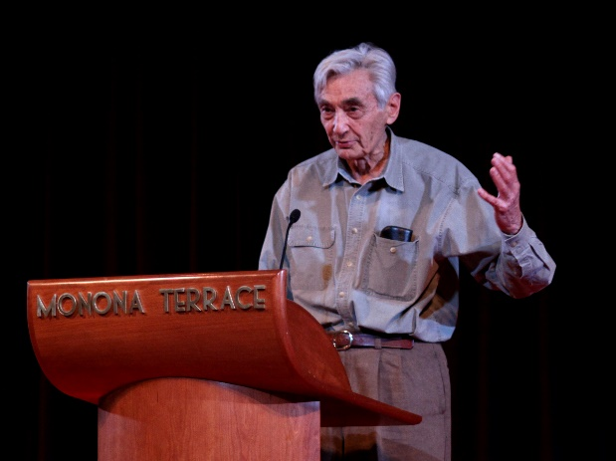  Howard Zinn  Zinn, H. (2010). A people’s history of the United States. New York, NY: Harper Perennial. “To emphasize the heroism of Columbus and his successors as navigators and discoverers, and to de-emphasize their genocide, is not a technical necessity but an ideological choice. It serves—unwittingly—to justify what was done.  My point is not that we must, in telling history, accuse, judge, condemn Columbus in absentia. It is too late for that; it would be a useless scholarly exercise in morality. But the easy acceptance of atrocities as a deplorable but necessary price to pay for progress (Hiroshima and Vietnam, to save Western civilization; Kronstadt and Hungary, to save socialism; nuclear proliferation, to save us all)—that is still with us. One reason these atrocities are still with us is that we have learned to bury them in a mass of other facts, as radioactive wastes are buried in containers in the earth. We have learned to give them exactly the same proportion of attention that teachers and writers often give them in the most respectable of classrooms and textbooks. This learned sense of moral proportion, coming from the apparent objectivity of the scholar, is accepted more easily than when it comes from politicians at press conferences. It is therefore more deadly.” (p. 9)  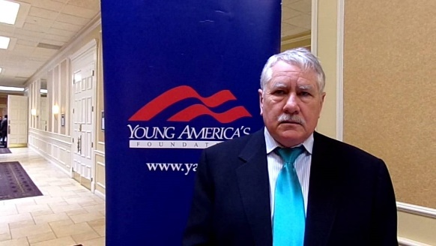  Larry Schweikart  Schweikart, L., & Allen, M. (2004). A patriot’s history of the United States: From Columbus’s Great Discovery to the war on terror. New York, NY: Sentinel. “The five‐hundred‐year anniversary of Columbus’s discovery was marked by unusual and strident controversy. Rising up to challenge the intrepid voyager’s courage and vision—as well as the establishment of European civilization in the New World—was a crescendo of damnation, which posited that the Genoese navigator was a mass murderer akin to Adolf Hitler.  Even the establishment of European outposts was, according to the revisionist critique, a regrettable development. Although this division of interpretations no doubt confused and dampened many a Columbian festival in 1992, it also elicited a most intriguing historical debate: did the esteemed Admiral of the Ocean Sea kill almost all the Indians? A number of recent scholarly studies have dispelled or at least substantially modified many of the numbers generated by the anti‐Columbus groups, although other new research has actually increased them.” (pp. 7–8)

